Rectangle–Circular Mixed Shapes
# Source: AI Source: Provided by: [Data Path: Persons Table -> ID Column: 1, Name_En Column: Motasem Essam] -> From: [ChatGPT] on [7/25/2026]
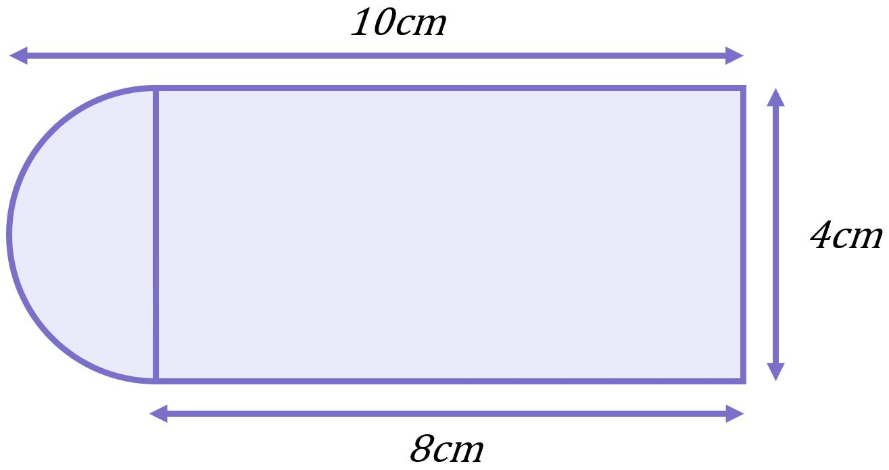
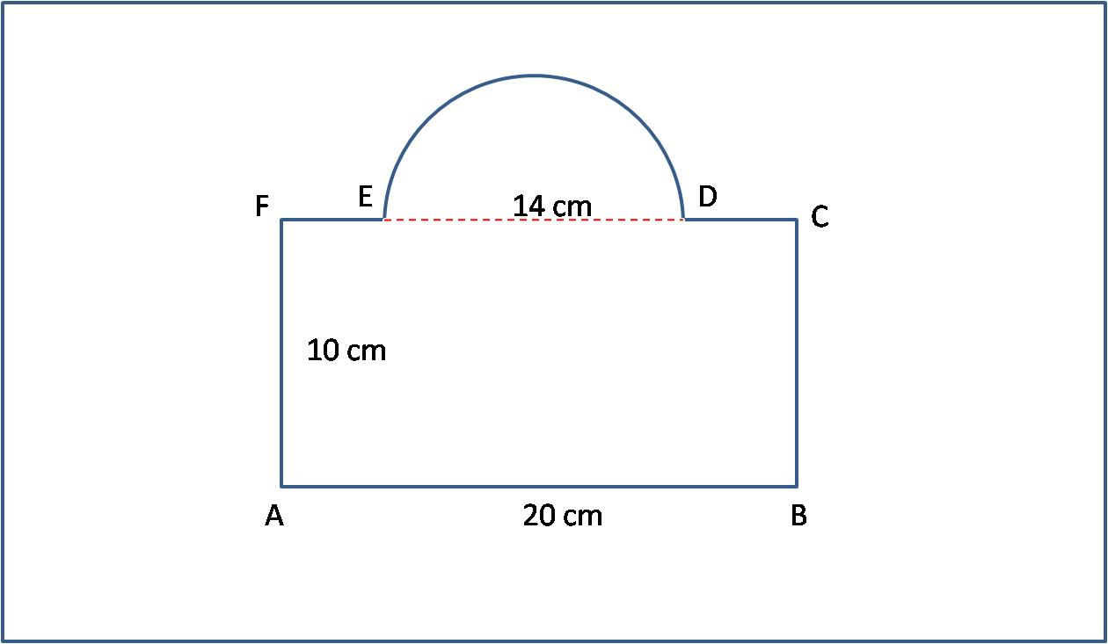
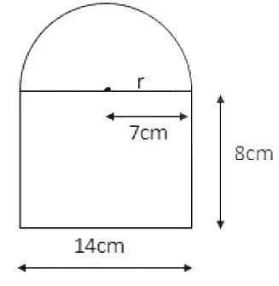
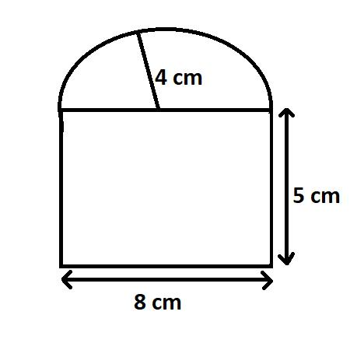
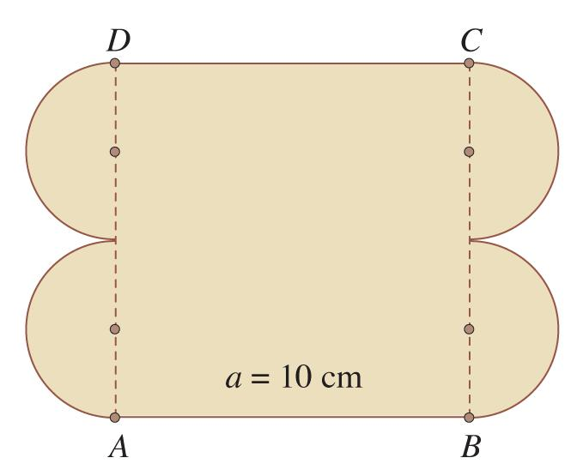

Definition
# Source: AI Source: Provided by: [Data Path: Persons Table -> ID Column: 1, Name_En Column: Motasem Essam] -> From: [ChatGPT] on [7/25/2026]
A Rectangle–Circular Mixed Shape is an irregular composite shape formed by combining a rectangle with one or more circular elements or circular arcs.
In simple terms:
It is a shape that combines a rectangular part with a circular or curved circular part.
$$\boxed{\text{Rectangle–Circular Mixed Shape}=\text{Rectangle}+\text{Circular Element}}$$

Characteristics
# Source: AI Source: Provided by: [Data Path: Persons Table -> ID Column: 1, Name_En Column: Motasem Essam] -> From: [ChatGPT] on [7/25/2026]
A Rectangle–Circular Mixed Shape typically:
- Contains a rectangular component.
- Contains at least one circular component or circular arc.
- Has both straight and curved boundaries.
- Has a mixed boundary.
- Is usually classified as an irregular mixed shape rather than a single basic shape.
- Can often be decomposed into a rectangle and one or more circular parts.
- May be formed by adding or subtracting circular portions.

Common Types

1. Rectangle + Semicircle
# Source: AI Source: Provided by: [Data Path: Persons Table -> ID Column: 1, Name_En Column: Motasem Essam] -> From: [ChatGPT] on [7/25/2026]

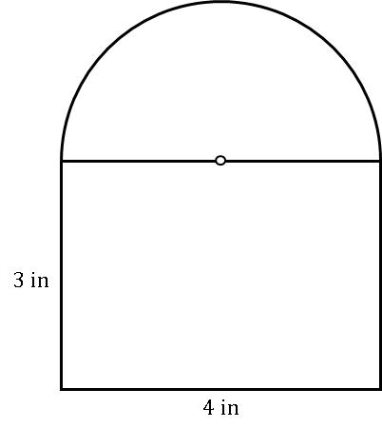

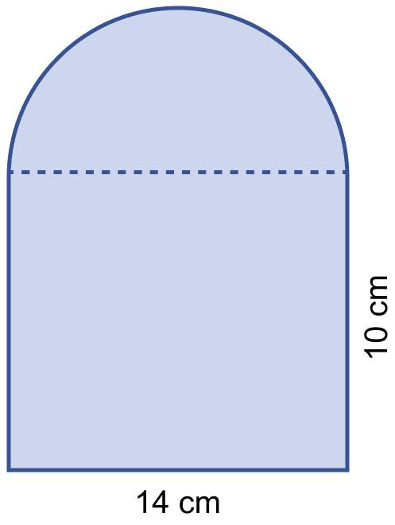
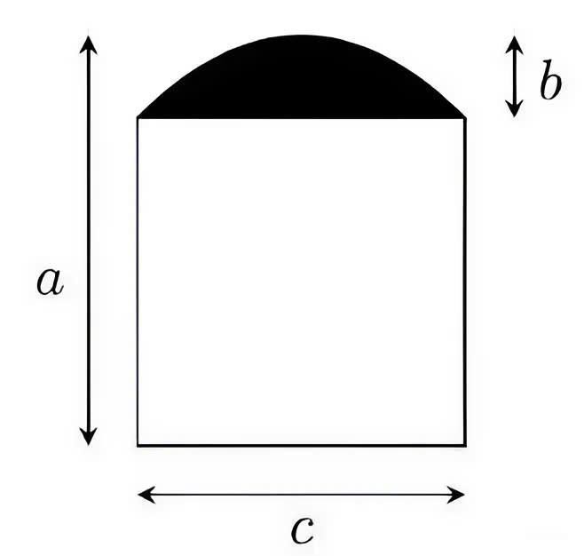
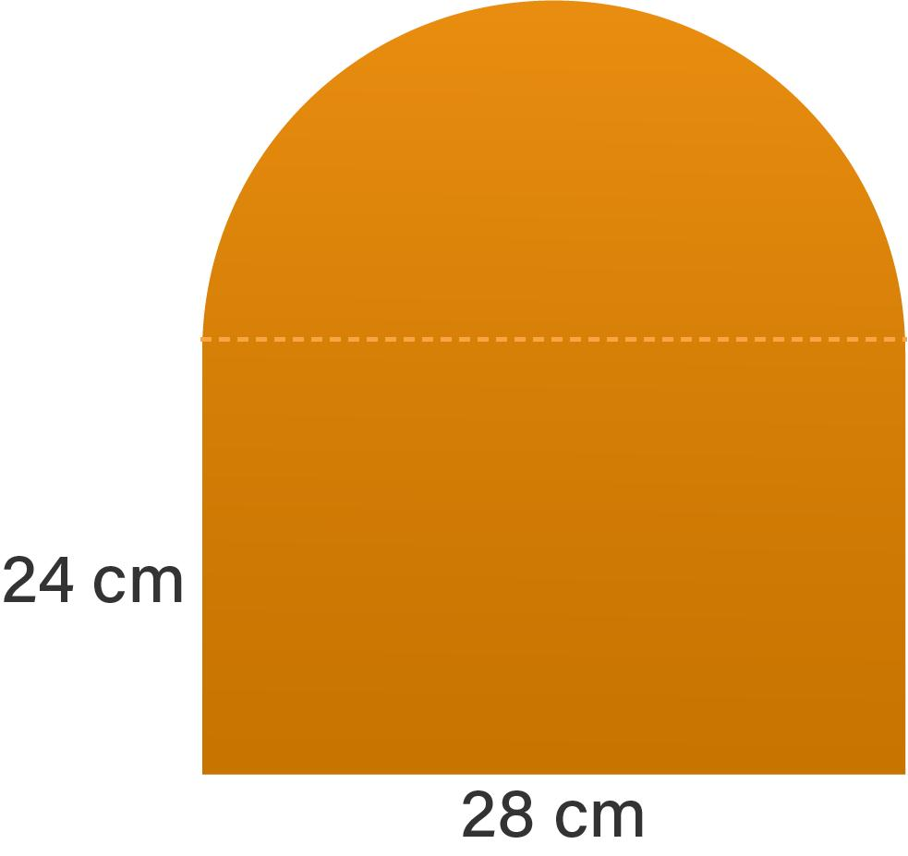
A semicircle is attached to one side of a rectangle.
$$A_{\text{total}}=A_{\text{rectangle}}+A_{\text{semicircle}}$$

2. Rectangle + Two Semicircles
# Source: AI Source: Provided by: [Data Path: Persons Table -> ID Column: 1, Name_En Column: Motasem Essam] -> From: [ChatGPT] on [7/25/2026]
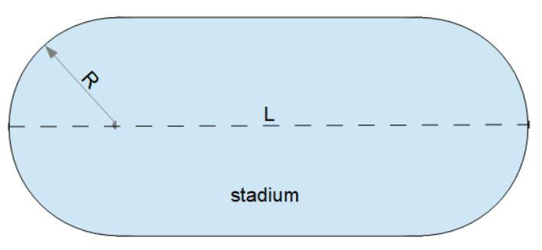
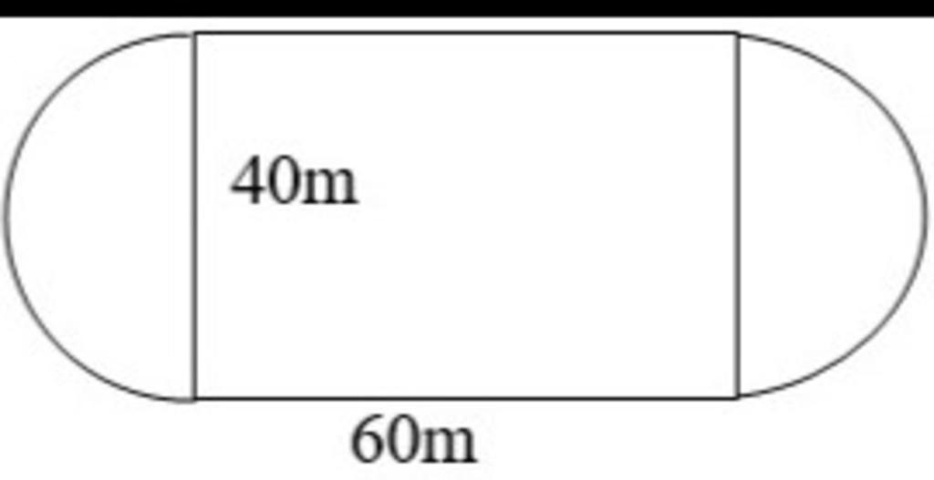
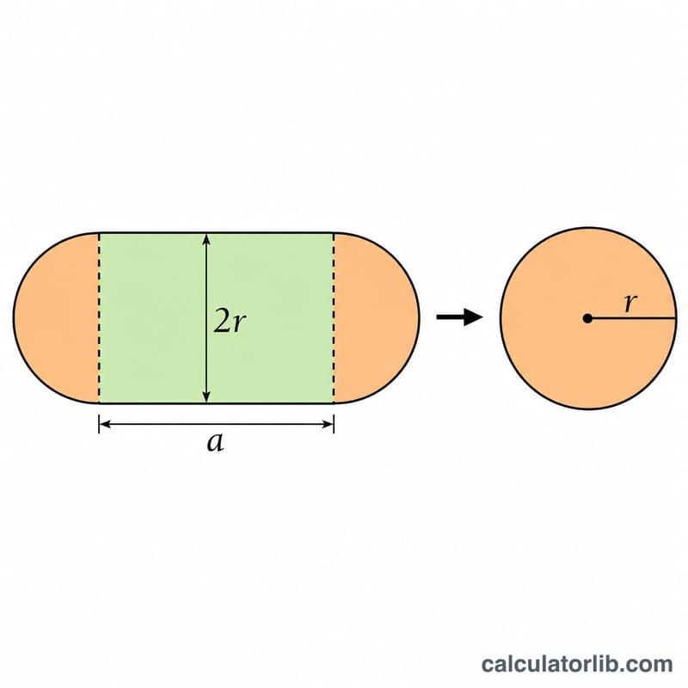
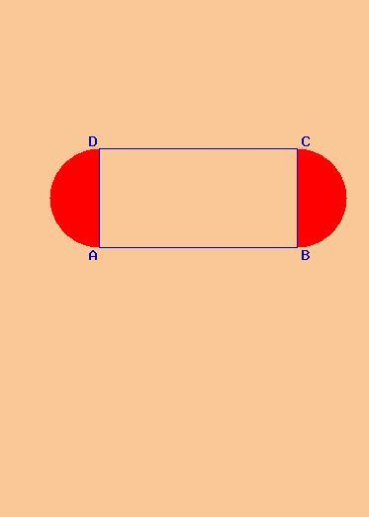
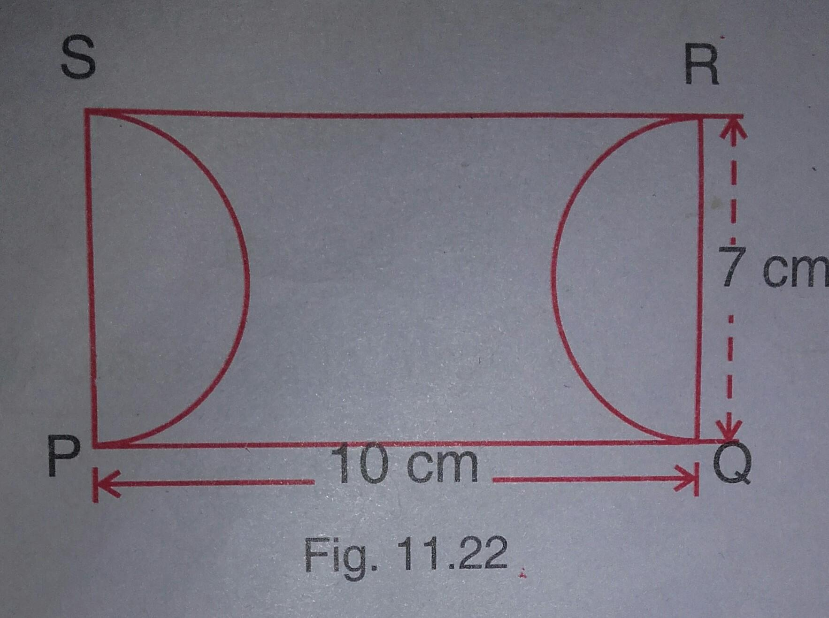
A rectangle can have a semicircle attached to each of two opposite sides.
The two semicircles together form a complete circle:
$$A_{\text{total}}=A_{\text{rectangle}}+πr^{2}$$
This type is sometimes called a stadium or capsule shape when the two semicircles have the same radius.

3. Rectangle + Quarter Circle
# Source: AI Source: Provided by: [Data Path: Persons Table -> ID Column: 1, Name_En Column: Motasem Essam] -> From: [ChatGPT] on [7/25/2026]
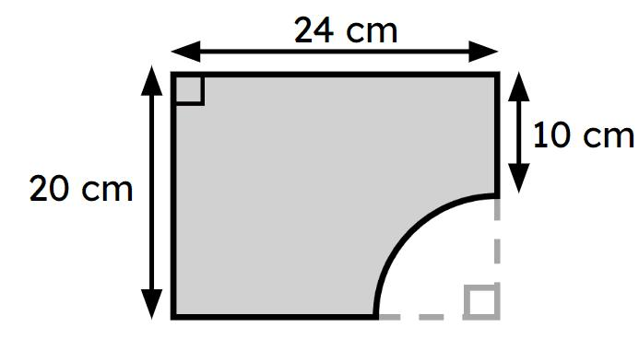
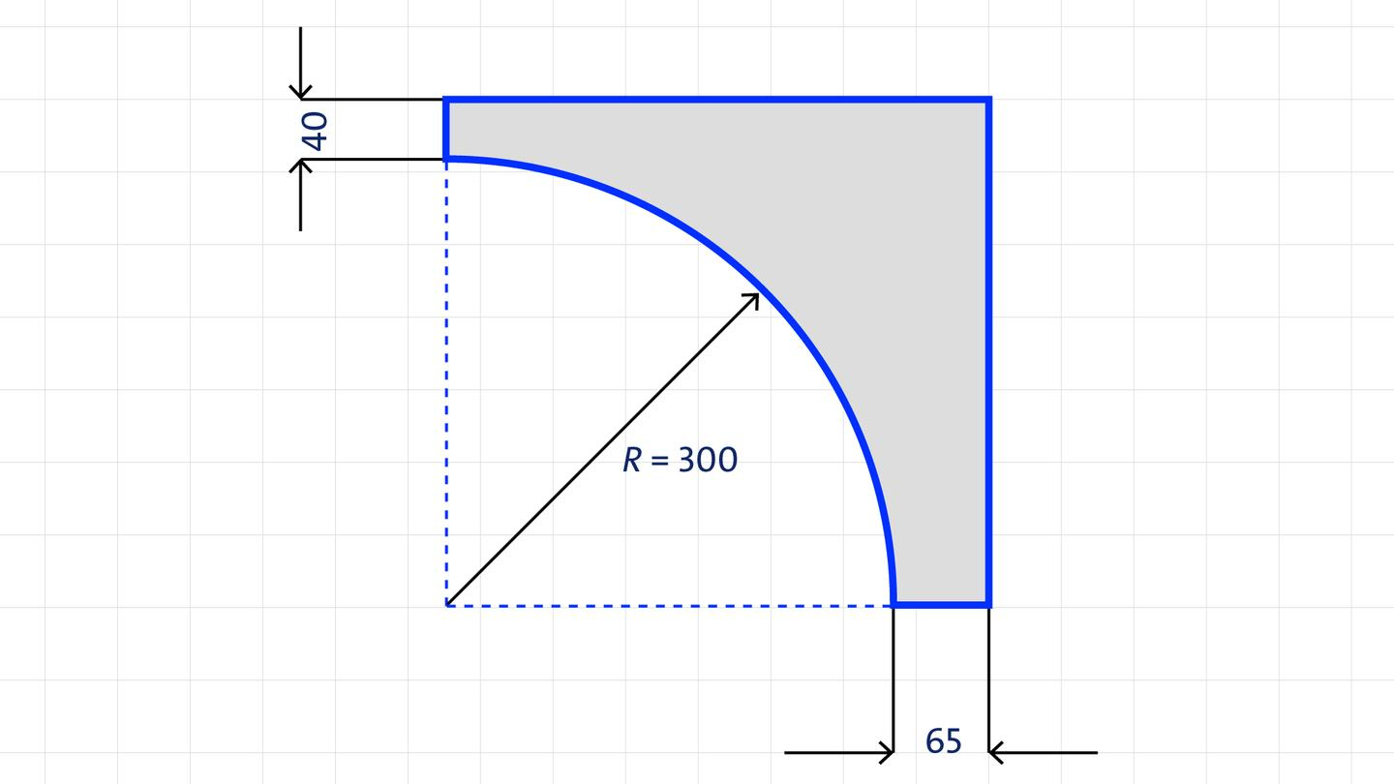
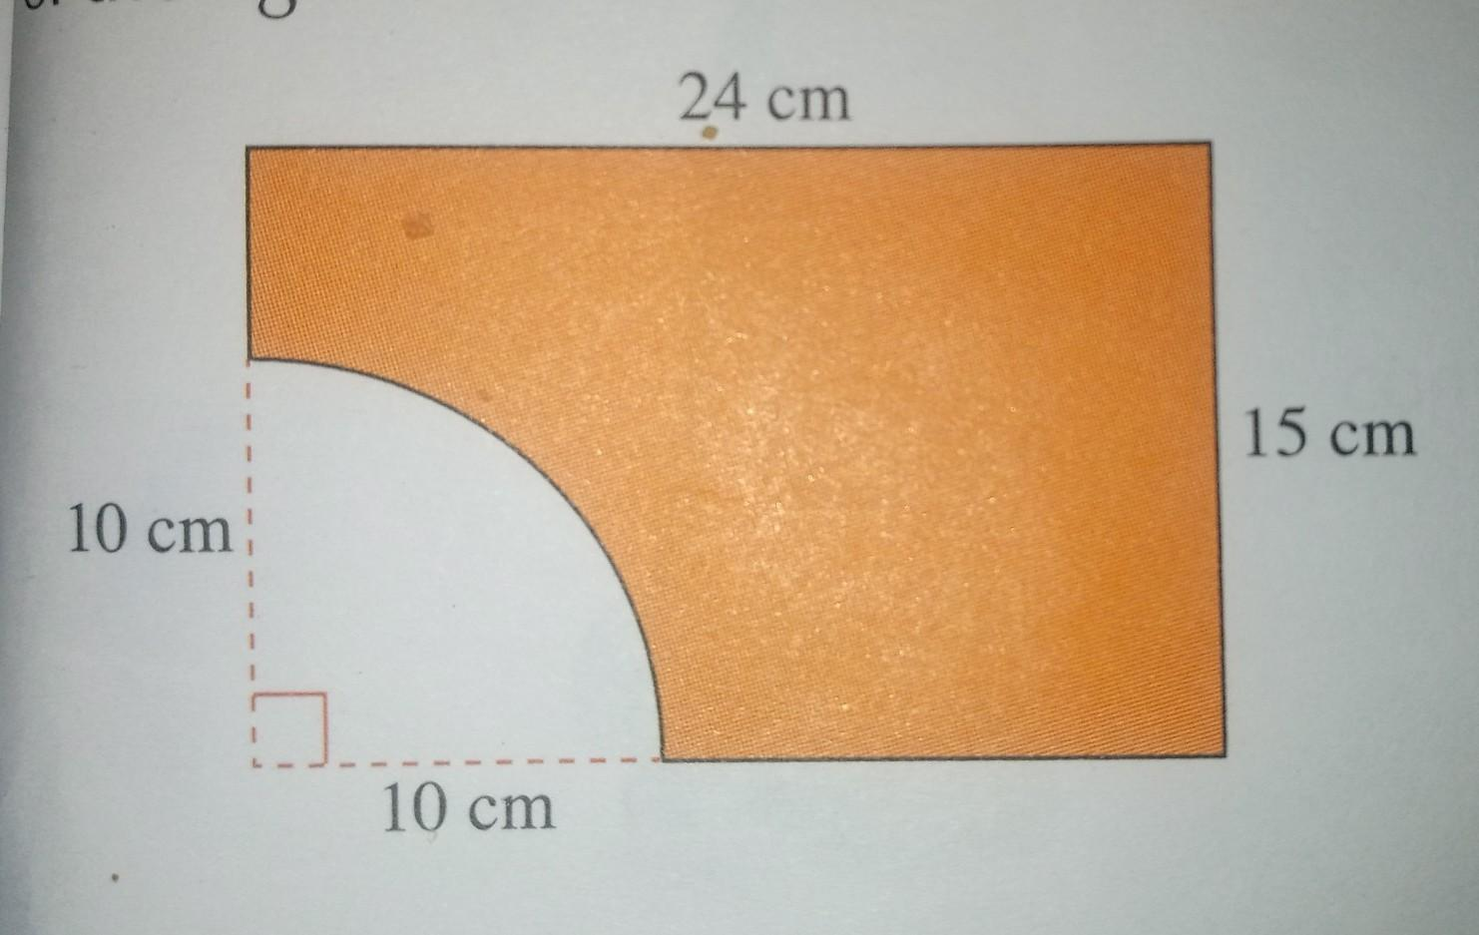
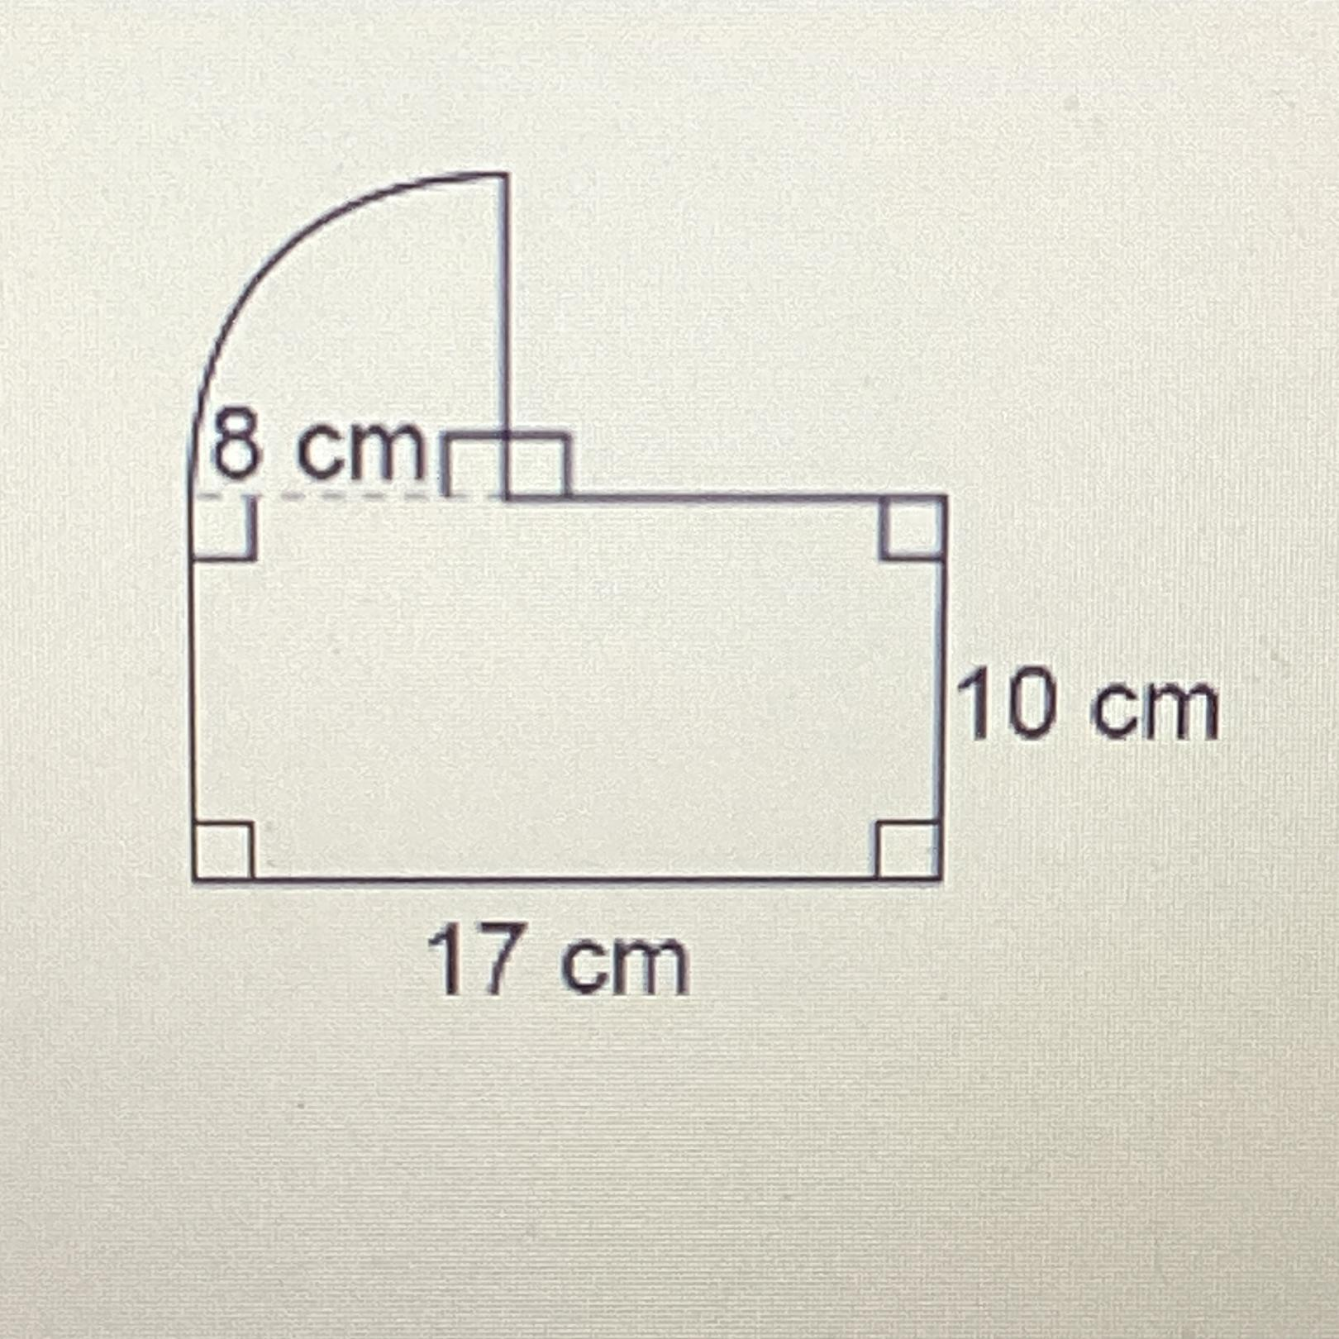
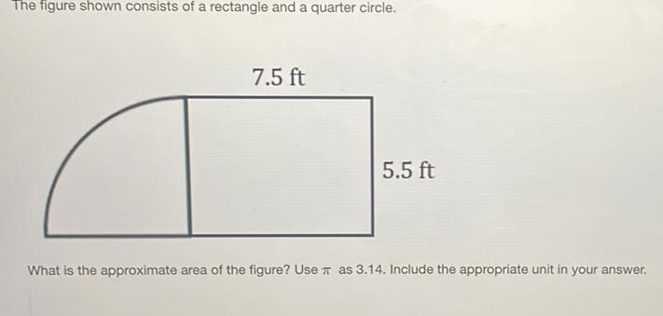
A quarter-circle arc can replace or extend part of a rectangular boundary.
$$A_{\text{quarter circle}}=\frac{14}{π}r^{2}$$

4. Rectangle + Circular Segment
# Source: AI Source: Provided by: [Data Path: Persons Table -> ID Column: 1, Name_En Column: Motasem Essam] -> From: [ChatGPT] on [7/25/2026]
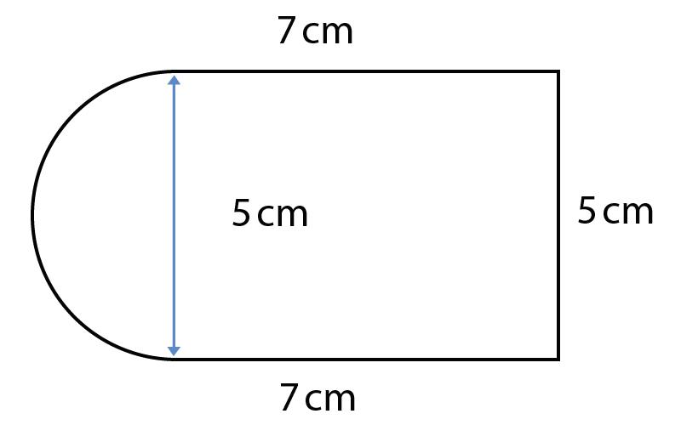
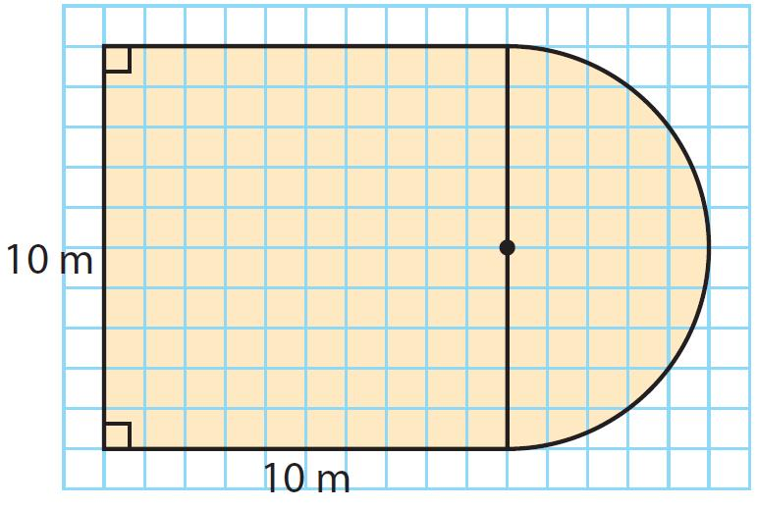

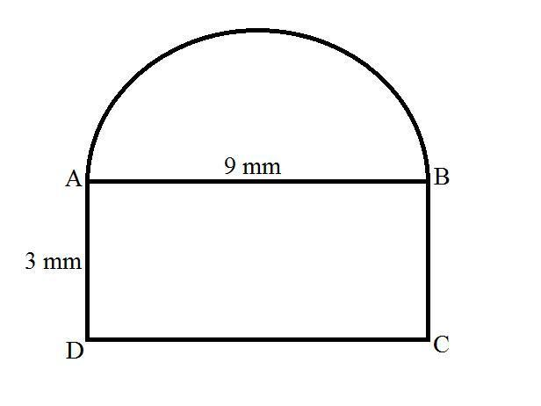
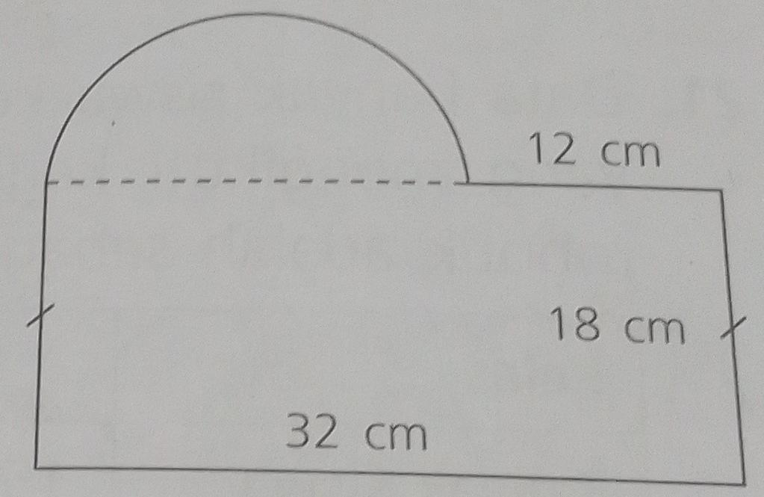
A portion of a circle can be combined with a rectangle to create a more complex boundary.

5. Rectangle with Circular Cutout
# Source: AI Source: Provided by: [Data Path: Persons Table -> ID Column: 1, Name_En Column: Motasem Essam] -> From: [ChatGPT] on [7/25/2026]
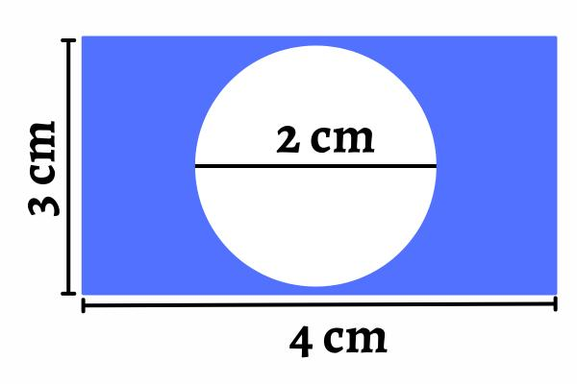
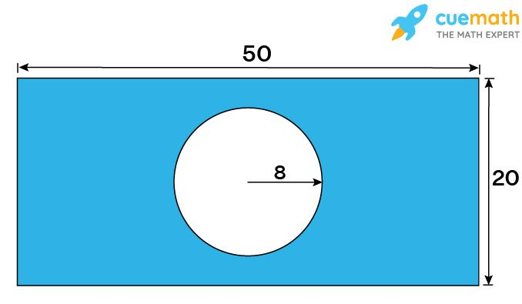
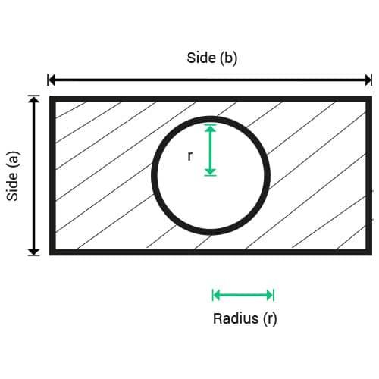
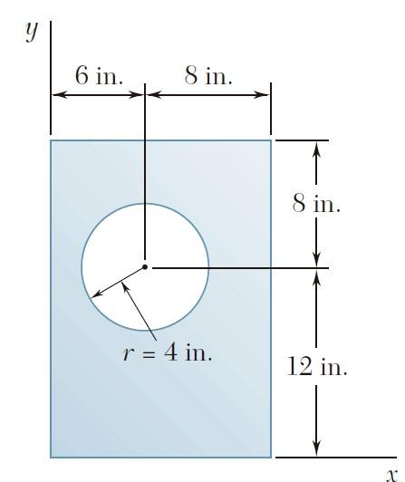
A circular region can be removed from a rectangle.
$$\boxed{A_{\text{remaining}}=A_{\text{rectangle}}-A_{\text{circle}}}$$

6. Rectangle with Multiple Circular Cutouts
# Source: AI Source: Provided by: [Data Path: Persons Table -> ID Column: 1, Name_En Column: Motasem Essam] -> From: [ChatGPT] on [7/25/2026]
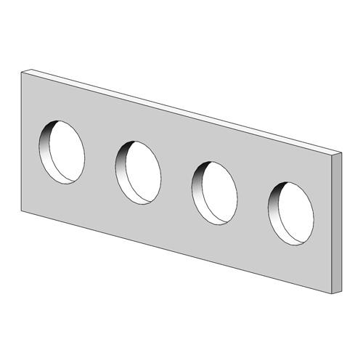
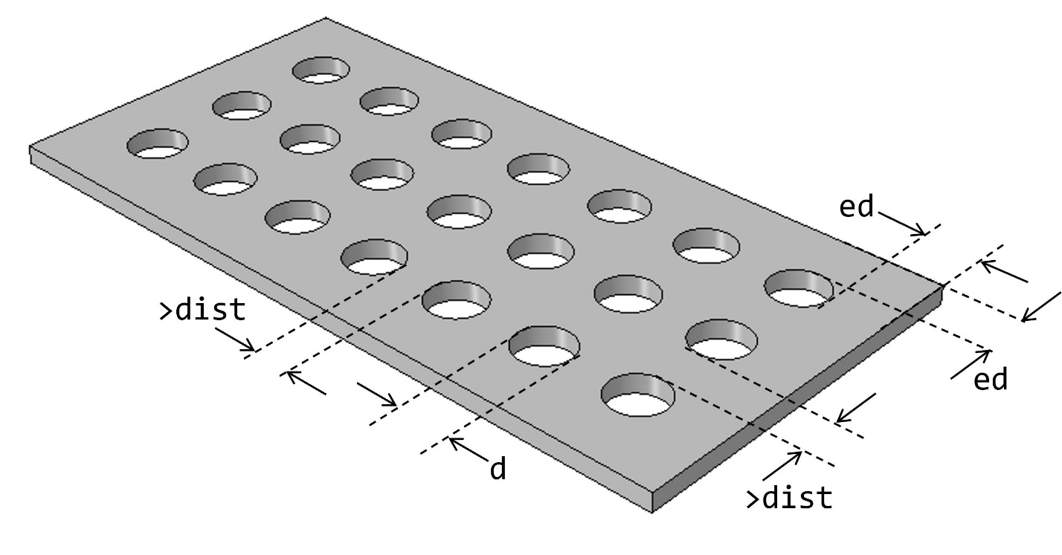
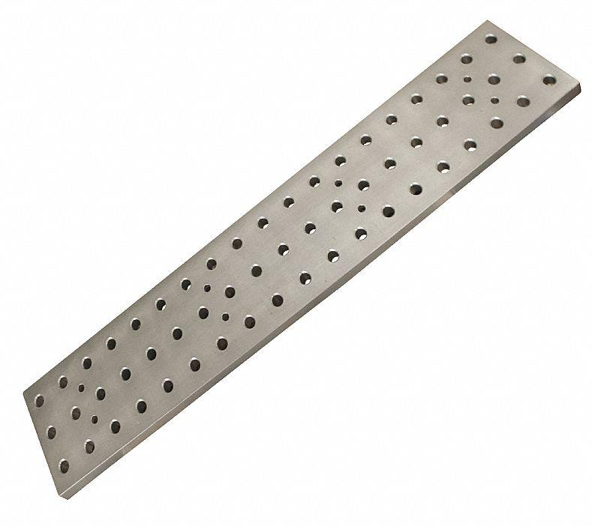
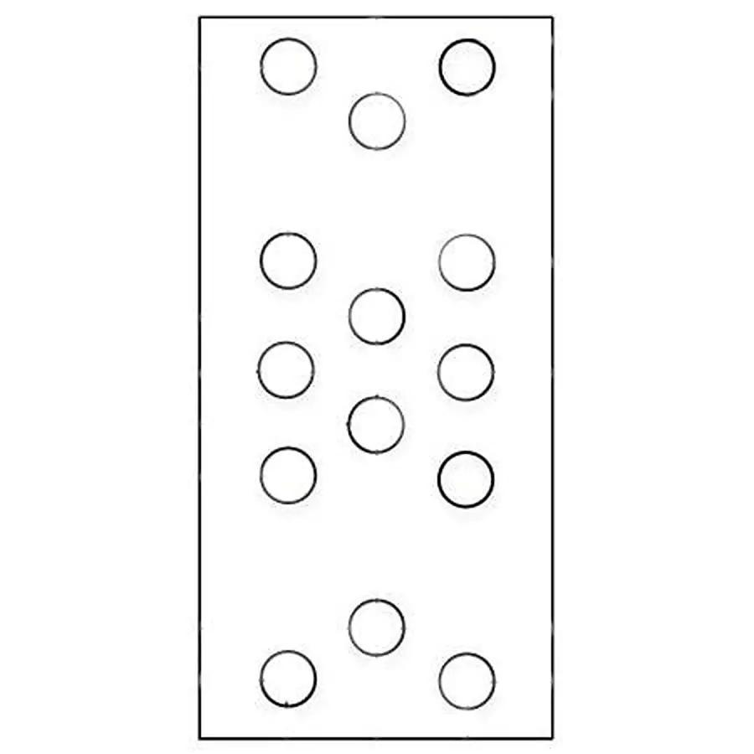
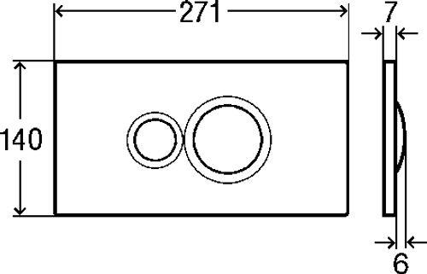
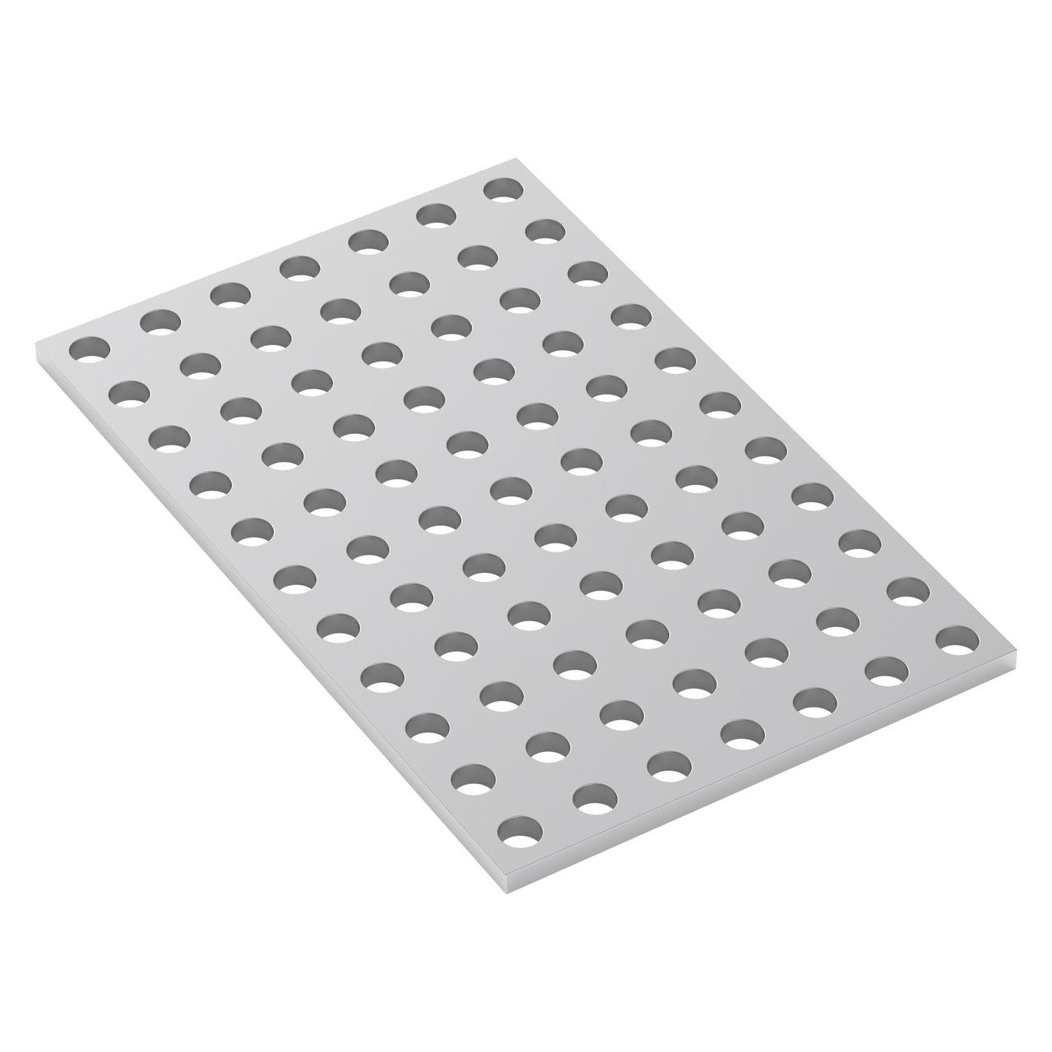
Several circular regions can be removed from a rectangular region.
$$A_{\text{remaining}}=A_{\text{rectangle}}-\sum{A_{\text{circles}}}$$

Boundary Classification
# Source: AI Source: Provided by: [Data Path: Persons Table -> ID Column: 1, Name_En Column: Motasem Essam] -> From: [ChatGPT] on [7/25/2026]
A Rectangle–Circular Mixed Shape has two types of boundary:
$$\boxed{\text{Mixed Boundary}=\text{Straight Segments}+\text{Circular Arcs}}$$
The straight portions come from the rectangle, while the curved portions come from the circular components.

Area
# Source: AI Source: Provided by: [Data Path: Persons Table -> ID Column: 1, Name_En Column: Motasem Essam] -> From: [ChatGPT] on [7/25/2026]
The area is normally calculated by decomposing the shape.
For a rectangle plus a semicircle:
$$\boxed{A=lw+\frac{1}{2}πr^{2}}$$
For a rectangle plus a complete circle:
$$\boxed{A=lw+πr^{2}}$$
For a rectangle with a circular cutout:
$$\boxed{A=lw-πr^{2}}$$

Perimeter
# Source: AI Source: Provided by: [Data Path: Persons Table -> ID Column: 1, Name_En Column: Motasem Essam] -> From: [ChatGPT] on [7/25/2026]
The perimeter combines the straight sides of the rectangle with the lengths of the circular arcs.
For a semicircle:
$$L_{\text{arc}}=πr$$
Therefore, a typical rectangle–semicircle shape has:
$$\boxed{P=\sum{L_{\text{straight}}}+πr}$$
For a full circle:
$$C=2πr$$

Rectangle–Circular vs. Polygon–Circular Mixed Shapes
# Source: AI Source: Provided by: [Data Path: Persons Table -> ID Column: 1, Name_En Column: Motasem Essam] -> From: [ChatGPT] on [7/25/2026]
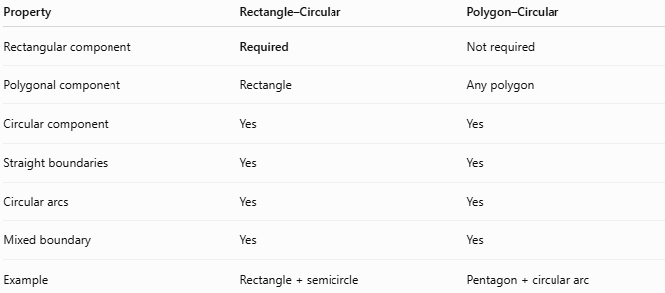
Property | Rectangle–Circular | Polygon–Circular
Rectangular component | Required | Not required
Polygonal component | Rectangle | Any polygon
Circular component | Yes | Yes
Straight boundaries | Yes | Yes
Circular arcs | Yes | Yes
Mixed boundary | Yes | Yes
Example | Rectangle + semicircle | Pentagon + circular arc
A rectangle is itself a special type of quadrilateral, so:
$$\boxed{\text{Rectangle–Circular Mixed Shape}⊂\text{Polygon–Circular Mixed Shapes}}$$
if your classification treats a rectangle as a polygonal component.

Key Points
# Source: AI Source: Provided by: [Data Path: Persons Table -> ID Column: 1, Name_En Column: Motasem Essam] -> From: [ChatGPT] on [7/25/2026]
A Rectangle–Circular Mixed Shape combines:
$$\boxed{\text{Rectangle}+\text{Circular Element}}$$
It has:
- Straight rectangular boundaries.
- Circular or arc-shaped boundaries.
- A mixed boundary.
- A composite structure.
- Usually an irregular overall form.
Its area and perimeter can generally be calculated by decomposing it into rectangles, circles, semicircles, quarter-circles, and circular segments.

Conclusion
# Source: AI Source: Provided by: [Data Path: Persons Table -> ID Column: 1, Name_En Column: Motasem Essam] -> From: [ChatGPT] on [7/25/2026]
Rectangle–Circular Mixed Shapes are irregular mixed shapes that combine a rectangular component with circular components or circular arcs. Common examples include rectangles with semicircular ends, rectangles with quarter-circle extensions, rectangular regions with circular cutouts, and shapes containing multiple circular features. They are especially useful in composite-area geometry, engineering, architecture, CAD, product design, and real-world shape modeling.

